**DEVELOPMENT OF A ECOMMERCE SITE FOR ONLINE SHOPING**



*A Project Report*

*Submitted to the Department of Computer Science and Engineering, University of Rajshahi for the partial fulfillment of the requirements for the degree of*

*B.Sc Engineering in Computer Science & Engineering*

SUBMITTED BY

### ID: 1611076116

Session: 2015-16

Course code: CSE 4292

DEPARTMENT OF COMPUTER SCIENCE AND ENGINEERING UNIVERSITY OF RAJSHAHI

***Dedicated***

***To***

***My Parents***

**Acknowledgement**

I would like to express my deep gratitude to my supervisor supervisor Md. Morshedul Arefine, Associate professor, Department of Computer Science and Engineering, University of Rajshahi for his kind suggestion of the topic, great supervision and guidance throughout the duration of my project. His dedication, collaboration and interaction was a key factor in the success of my project.

I also would like to thank all of my respectable teachers of the Department of Computer Science and Engineering, University of Rajshahi for their valuable suggestions and academic help during the course work.

Finally, I thank Almighty Allah from the deepest of my heart for making me able to do this project work.

**ABSTRACT**

My project is a web based online buying and selling platform. This is a website which helps consumers to find and buy all type of goods on internet. It is useful in the way that it makes an easier way to buy and sell goods online. My projectis an interactive e-commerce solution providing users with an opportunity to buy and sell goods. It is a online platform which deals with consumer and seller in the same field.

In this website we have basically 3 modules. The first module includes the customer module, second module includes local admin module and third module include super admin module.

The customer have to register for any enquiry related to goods. The registered customer can view details of goods and he/she can buy goods of his/her need. He/she has to pay and will get home delivery.

The local admin module contains the access of admin page on the website. The admin can change everything in the website under a specific shop. He have the ability to add, delete, and update any information regarding the shop.

The super admin give authentication of local admin under a specific shop. The super admin can insert, delete and update shop name and local admin.

**INDEX**

|  |  |  |
| --- | --- | --- |
| **No.** | **Topics** | **Page** |
| **Chapter[1]: Introduction** | | |
| 1.1 | Introduction | 1 |
| 1.2 | Objectives | 2 |
|  |  |  |
|  |  |  |
|  |  |  |
| **Chapter[2]: System Requirement** | | |
| 2.1 | Software needed to run this project | 5 |
| 2.2 | Scripting Language (PHP) | 6 |
| 2.3 | Apache Web Server | 6 |
| 2.4 | MySQL relational Database | 7 |
| 2.5 | HTML (Hypertext Markup Language) | 8 |
| 2.6 | CSS (Cascading Style Sheet) | 9 |
| 2.7 | JavaScript | 10 |
| 2.8 | Bootstrap( framework) | 11 |
| **Chapter 3|: System Development** | | |
| 3.1 | Project Planning and Scheduling | 14 |
| 3.2 | Project Development Approach Project | 14 |
| 3.3 | Types of Software Process Model Management | 15 |
| 3.4 | Waterfall Model | 16 |
| 3.5 | Project Plan | 18 |
| 3.6 | Milestones | 18 |
| 3.7 | Roles and Responsibility | 19 |

|  |  |  |
| --- | --- | --- |
| **Chapter[4]: System Analysis** | | |
| 4.1 | Existing System & its Problem | 22 |
| 4.2 | Proposed System | 22 |
| 4.3 | Feasibility Study | 23 |
| **Chapter[5]: System Design** | | |
| 5.1 | UML Diagram | 26 |
| 5.2 | Use Case Diagram | 27 |
| 5.3 | E-R Diagram | 30 |
| 5.4 | Table Structure | 31 |
| **Chapter[6]: System Implementation and Testing** | | |
| 6.1 | Project Module | 37 |
| 6.2 | Screens | 38 |
| 6.3 | Testing | 48 |
| **Chapter[7]:Conclusion** | | |
| 7.1 | Limitations | 50 |
| 7.2 | Future Plan | 50 |
| 7.3 | Conclusion | 51 |
| Reference | | |

*Chapter One*

Introduction

### **1.1 INTRODUCTION**

### One of the beauties of the Web is that anybody can establish himself or herself with a Web site that can be access by a worldwide consumer base That is why Electronics Commerce over the Internet is one of the most widely and rapidly growing areas in today's business, which in turn is changing the economy of a country in the positive direction.

### E-commerce is now such a hot topic of the Internet that it has almost become a cliché. But nevertheless, it is now the most fruitful way of doing business. A recent survey revealed that the total number of Internet users from about 900 million, an awesome figure if one takes into account the prospect of doing business with those people, the number of which is increasing by the day. The amount is going to be even bigger as the current business organizations of the world are showing a trend towards using the Internet as a part of their business policy or so to say in business speak advertising policy. If one were to give a list of the companies profited because of doing business over the Internet, it would at least take proportion of an entire book. But it is indeed profitable enough to set up a business through the Internet framework. The truth is over the world it's no longer a symbol of aristocracy to setup an Internet based business but a competitive obligation because a business without an Internet framework would have very hard times to cope up with its competitors as the days goes by

### 1.2OBJECTIVES

The present work is carried with the following objectives in mind

* To study the different commercial web sites in the internet and get idea about the construction, component and mechanism of a commerce site
* The different requirements for doing e-commerce are presented A commercial web site includes many phases with different needs These requirements are studied in detail.
* Understanding the Web programming concept. HTML, server-side scripting, database programming. socket programming are studied to develop the web site.
* Network infrastructure for Electronic is covered. Requirements to host a commercial website are presented.

*Chapter two*

System Requirement

**2.1 Software's needed to run this project:**

1. Operating System
2. Apache web server
3. PHP for server Side Scripting
4. MySQL relational Database
5. HTML (Hypertext markup language)
6. CSS (Cascading Style Sheet)
7. JavaScript
8. Front-end frameworks: Twitter Bootstrap, Jquery
9. Back-end framework: Laravel 5.4
10. Font Awesome
11. Sublime Text3
12. Ajax

2.2.1 Operating System

Any kind of operating system can be used for this project, because the server and programming language I have used can be run at any OS. But I have used Windows OS(8.1) to implement my project. This OS is better available and I operate this OS easily. It’s graphical interface is so user friendly that I think.

2.2.2 Apache web server

The Apache HTTP Server, commonly referred to as Apache is a web server application notable for playing a key role in the initial growth of the World Wide Web. This is based on the NCSA HTTP server. This server serves more than 100 million websites.

Apache web server is developed and managed by an open community of developers. They are under the auspices of the Apache Software Foundation. On Unix-like System is used for this software. Those OS are Unix FreeBSE, Linux, Solaris, Novell NetWare, OS X, Microsoft Windows, OS/2, TPF and eComStation. Apace is open source software.

2.2.3 PHP Server Side Script

PHP is a programming language devised by Rasmus Lerdorf in 1994 for building dynamic, interactive web stories.

* PHP means PHP: Hypertext Preprocessor. It was initially developed for HTTP usage logging and server-side form generation in UNIX. PHP originally stood for “Personal Home Page”.
* PHP2 (1995) transformed the language into server-side embedded scripting language. Added database support, file uploads, variables, arrays recursive functions, conditionals, iteration, regular expression etc.
* PHP 3 (1998) added support for ODBC data sources, multiple platform support, email protocols (SNMP, IMAP) and new parser.
* PHP 4 became an independent component of the web server for added efficiency.
* PHP is a server-side scripting language designed for web development but also used as a general-purposes programming language. PHP is now installed on more than 244 million website and 2.1 million web servers.
* PHP code is interpreted by a web server with a PHP processor module, which generates the resulting web page: PHP commands can be embedded directly into an HTML source document rather than calling external file to process data.
* PHP is free software released under the PHP License, which is incompatible with the GNU General Public License (GPL) due to restrictions on the usage of the term PHP. PHP can be deployed on most web servers and also as a standalone shell on almost every operating system.

2.2.4 MySQL relational Database

MySQL is the world’s most widely used open source relational database management system (RDBMS) that runs as a server providing multi-user access to a number of databases, through SQLite probably has more total embedded deployments. It is named after co-founder Michael Widenius’s daughter, MySQL phrase stands for Structured Query Language.

The MySQL development project has made its source code available under the terms of the GNU General Public License, as well as under a variety of proprietary agreements.

Basic operation of MySQL:

* Create Table
* Insert records
* Load data
* Retrieve records
* Update records
* Delete records
* Modify table
* Join Table
* Drop Table
* Optimize table
* Count, Like, Order by, Group by
* More advanced ones (sub-queries, stored procedures, triggers, views…)

2.2.5 HTML (Hypertext Markup Language)

Hypertext Markup Language (HTML) is the main markup language for creating web pages and other information that can be displayed in a web browser.

HTML is written in the form of HTML elements consisting of tags enclosed in angle brackets within the web page content. HTML tags most commonly come in pairs like <h1> and </h1>, although some tags and the second tag is the end tag. In between these tags web designers can add text, further tags, comments and other types of text-based content.

The Purpose of a web browser is to read HTML documents and compose them into visible or audible web pages. The browser does not display the HTML tags, but uses the tags to interpret the content of the page.

2.2.6 CSS (Cascading Style Sheet)

CSS is a style sheet language used for describing the presentation semantics of a document written in markup language. It’s most common application is to style web pages written in HTML and XHTML, but the language can also be applied to any kind of XML document, including plain XML, SVG and XUL.

CSS is designed primarily to enable the separation of document from document presentation, including elements such as the layout, colors and fonts. This separation can improve content accessibility, provide more flexibility and control in the specification of presentation characteristics, enable multiple pages to share formatting and reduce complexity and repetition in the structural content CSS can also allow the same markup page to be presented in different styles for different rendering methods, such as on-screen, in print, by voice and on Braille-based, tactile devices.

CSS specifies a priority scheme to determine which style rules apply if more than one rule matches against a particular element. In this so-called cascade, priorities or weights are calculated and assigned to rules, so that the results are predictable.

2.2.7 JavaScript

JavaScript (JS) is an interpreted computer programming language. As part of web browsers, implementations allow client-side scripts to interact with the user, control the browser, communicate asynchronously and alter the document content that is displayed. It has also become common in server-side programming, game development and the creation of desktop applications.

JavaScript is a prototype-based scripting language with dynamic typing and has first-class functions. Its syntax was influenced by C.

JavaScript’s use in applications outside of web pages for example, in PDF documents, site-specific browsers and desktop widgets is also significant. Newer and faster JavaScript for server-side web applications.

2.2.8 Frameworks

Bootstrap is a free collection of tools for creating websites and web applications. It contains HTML and CSS-based design templates for typography, forms, buttons, navigation and other interface components, as well as optional JavaScript extension.

JQuery is a multi-browser JavaScript Library designed to simplify the client-side scripting of HTML. It was released in January 2006 at Bar Camp NYC by John Resig. It is currently developed by a team of developers led by Dave Methvin. Used by over 65% of the 10,000 most visited websites, jQuery is the most popular JavaScript library in use today.

JQuery is free, open source software, licensed under the MIT license. JQuery’s syntax is designed to make it easier to navigate a document, select DOM elements, create animations, handle events and develop Ajax applications. JQuery also provides capabilities for developers create plug-ins on top of the JavaScript library.

2.2.9 Database

* A Lightweight database management system connection abstract library.
* Extension of a PHP5 is written in a compiled language.
* It supports a huge number of database systems.
* We cannot rewrite many lines of DB code.
* Easy to install.
* We don’t need third parties.

2.2.10 Laravel 5.4

Laravel 5.4 is a PHP framework which is a good choice for the development of web applications. It’s easy, flexible. It can be modified as per user requirements.

2.2.11 Font Awesome (Bootstrap Cheat Sheets)

Font Awesome is a font that's made up of symbols, icons, or pictograms that you can use in a webpage, just like a font. Font Awesome is well, awesome! It's a great icon based font that's very commonly paired-up with Bootstrap-based web projects. It has a library of 369 icons larger than the 200 native Bootstrap 3 glyphicons and can also unlock unique features like flipped, stacked or rotated icons

2.2.12 Sublime Text3

Sublime Text is a cross platform text and source code editor, with a Python API. The chrome was inspired by Vim. Its functionality is also extendable with sublime-packages; Sublime Text is not open source software nor free software, but some of the extending packages have free software licenses and are community-built and maintained.

2.2.13 Ajax

AJAX means Asynchronous JavaScript and XML. AJAX is a technique for creating fast and dynamic web pages. AJAX allows web pages to be updated asynchronously by exchanging small amounts of data with the server behind the scenes. This means that it is possible to update parts of a web page, without reloading the whole page.

*Chapter three*

System Development

**3.1 Project Planning and Scheduling**

Project planning establishes a plan for the software engineering work that follows. It describes the technical tasks to be conducted, the risks that are likely, the resources that will be required, the work product to be produces, and a work schedule.

Project scheduling is an activity that distributes estimated effort across the planned project duration by allocating the effort to specific software engineering tasks. It is important to note, however, that the schedule evolves overtime. During early stages of project planning, a macroscopic schedule is developed. This type of schedule identifies all software framework activities and the product functions to which they are applied. As the project gets under way, each entry on the macroscopic schedule is refined into a detailed schedule. Here, specific software tasks (required to accomplish an activity) are identified and scheduled.

**3.2 Project Development Approach**

To solve actual problems in an industry setting, a software engineer or a team of engineers must incorporate a development Strategy that encompasses the process, methods and tools layers and generic phase. This strategy is often referred to as a process model or a software engineering paradigm. A process Model for software engineering is often chosen based on the nature of the project and application, the methods and tools to be used, and the controls and deliverables that are required.

To solve actual problems in an industry setting, a software engineer or a team ol engineers must incorporate a development strategy that encompasses the process, methods, and tool layers.

**3.3Types of Software Process Models:**

* The Linear sequential Model ( Waterfall Model)
* The Prototyping Model
* The Rapid Application Development (RAD) Model
* The Incremental Model
* The Spiral Model
* The WINWIN Spiral Model
* The Concurrent Development Model
* The Formal Methods Model
* The Component Based Developed Model
* Fourth generation Technique ( 4GT)
* Agile Software Model

**Note:- Our software is based on Linear sequential Model ( Waterfall Model)**

**3.4 Waterfall Model**

The waterfall model derives its name due to the cascading effect from one phase to the other as is illustrated in above figure. In this model each phase well defines the starting and ending point, with identifiable deliveries to the next phase. Note that this model is sometimes referred to as the linear sequential model or the software life cycle model.

Starting from the existing Situation, we proceed towards the desired solution in a number of steps. At each of these steps the Waterfall Model is followed. Consider a Linear sequential Model lifecycle model which consists of repeating the following five phases in sequence:

The waterfall diagram is basically divided into the following 5 models.

* Requirement
* Design
* Implementation
* Verification
* Maintenance

Requirement analysis

Design

Implementation

Testing

Maintenance

**Requirement:-**

In the requirement phase the need to create the application is specified. What is the need of the system is defined. What information to be feeder to create the application will come under the requirement phase?

**Design:**

After the requirement phase the next phase is the Design phase where the application is designed according to the forms and other modules created. This phase is a much important phase because it will structure the layout of your application.

**Implementation:**

Implementation is the process of having a system personnel phase check out and put new equipment into use, train users, install new applications and construct any file of data needed to use it.

**Verification:**

After the whole application is being developed the main phase is the verification phase where the whole application is tested and verified to check the whole application.

**Maintenance:**

After the successful verification of the application the main phase is the maintenance phase where the application needs to be maintained for its Successful operation in future.

**3.5 Project Plan**

Project planning establishes a plan for the software engineering work that follows. It describes the technical tasks to be conducted, the risks that are likely, the resources that will be required, the work product to be produced, and a work schedule.

**3.6 Milestones**

Sometimes there are events external to your project that you want to track. If you cannot link to them because they are not in a Project Plan, you can create a milestone to represent them in your own project.

For example, you cannot begin a certain task until another company completes a software application you need to use. You can create a milestone in your project that represents the completion of that application and reminds you to track its progress.

Some milestones may need duration. For example, your project has an approval milestone at the end of a phase and you know that the approval process will take a week.

**3.7 Roles and Responsibility**

We members of the project have performed all the activities related to the analysis, design, documentations, coding and testing from start to end collectively by consensus.

**Analysis**

Understanding the requirements is among the most difficult tasks that face a software engineer. As far as our project is concerned, we had studied various projects related to administration. We also studied projects previously developed in this organization. We have analyzed this system for fifteen days.

**Designing**

Design engineering encompasses the set of principles, concepts and practices that lead to the development of high quality system or product design principles establishes an overriding philosophy that guides designers in the work that is performed. Software design sits at the technical kernel of software engineering and is applied regardless of the software process model that is used. Beginning once software requirements have been analyzed and modeled, software design is the last software engineering action within the modeling activity and sets the stage for construction.

As far as our project is concerned, we have designed the process model, data model and also viewer model that will be going to be implemented in the coding phase. To make an efficient development model we have developed various diagrams.

Like use case diagram, data flow diagram, context diagram to understand the user interactions, flow of data through the information system respectively.

**Coding**

On completion of design phase, we started coding

In case of responsibility

**Testing**

Software testing has a dual function; it is used to establish the presence of defects in the program and it is used to help judge whether or not the program is usable in practice. Thus software testing is used for validation and verification, which ensures that software confirms to its specification and meets the needs of the software customer. We have tested almost all interface components together and almost all tests have been successful. Testing has been applied for all the stages of the process.

*Chapter Four*

System Analysis

**4.1 Existing system & its problem.**

* Existing System is a Manual Management System or most of the system made for individual.
* Website maintenance is costly that’s why it is difficult for small retailer to open website.
* Different website use for different kind of products that is difficult for users to search a specific products.

**4.2 Proposed System**

The proposed system has:-

* The Proposed System provides opportunity to the retailer to operate business in this website.
* This project contains four modules. register/login module, supper admin module, admin module and customer module.
* Supper admin module is used to manage the admin panels, admin module can add, delete and update manufacture, categories or product. Customer module used to provide the provide the feedback of the products and can create account for him/her.
* Registered users can access the database of the products. Which will provide details about products and shop.
* The data can be accessed accurately.
* This system is very faster process.
* This system is user-friendly.
* This software will be more secure.

**4.3 Feasibility Study**

Feasibility study is conducted once the problem is clearly understood. Feasibility study is a high level capsule version of the entire system analysis and design process. The objective is to determine quickly at the minimum expense how to solve a problem. The purpose of feasibility is not to solve the problem but to determine if the problem is worth solving.

The system has been tested for feasibility in following points:-

1. Technical Feasibility

2. Economic Feasibility

3. Operational Feasibility

**1. Technical Feasibility**

The project entitles "Ecommerce Site for Online Shoping" is technically feasibility because of the below mentioned feature. The project was developed in php with html and CSS.

It provides a high level of reliability, availability and compatibility. All these make php an appropriate language for this project. Thus the existing website php is a powerful language.

2. Economic Feasibility

The computerized system will help in automating the selection leading the profits and details of the organization. With this software, the machine and manpower utilization are expected to go up by 60-80% approximately. The cost and time saving process is great in the system.

**3. Operational Feasibility**

In this project, the management will know the details of each operation where he has to do what and when. The data is very minimal to determine the operation structure for the staff.

*Chapter Five*

System Design

**5.1 UML diagrams**

**Introduction**

Design is the first step in the development phase for an engineered product or system. Design is the place where quality is fostered in software development. Design is the product or system. Software design serves as the foundation for all software engineers and software maintenance steps that follow. Without design we risk building an unstable design that will fail when small changes are made, one that may be difficult to test and one whose quantity cannot be accessed until late in the software engineering process. Taking software requirements specification document of analysis phase as input to the design phase we have drawn Unified modeling Language (UML) diagrams. UML depends on the visual modeling of the system. Visual modeling is the process of taking the information from the model and displaying it graphically using some sort of standard set of graphical elements. UML diagrams are drawn using the PaceStar UML Diagrammer Software. We seem to be able to understand complexity better when it is displayed to us visually as opposed to written textually. By producing visual models of a system, we can show how a system works on several levels. We can model and the interactions between the users and the system.

**Types of UML Diagrams**

Each UML diagram is designed to let developers and others view a software system from a different perspective in varying degrees of abstraction, UML diagram commonly created in visual modeling tools include.

5.2 Use case Diagram

l

Customers

View

Products detail

Shop detail

About

Contact Us

Log in

Order

Order detail

payment

Shipping detail

Database description:

After carefully understanding the requirements the entire data storage requirement is divided into tables. The tables are normalized to avoid any anomalies during the course of data entry.

Normalization:

It is a process of converting a relation to a standard form. The process is used to handle the problems that can arise due to data redundancy i.e repetition of data in database, maintain data integrity as well as handling problems that can arise due to insertion updating, deletion anomalies.

First Normal Form:

A relation is said to be in first normal form if the values in the relation are atomic for every attribute in the relation. By this we mean we simply have no attribute in the relationship. BY this we mean simply that no attribute value can be a set of values or as it is sometimes expressed a repeating group.

Second Normal Form:

A relation is said to be in second Normal form if it is in first normal form and it should satisfy any one of the following rules. Primary key is a not a composite primary key No non key attributes are present every non key attribute is fully functionally dependent on the full set of primary key.

Third Normal Form:

A relation is said to be in third normal form if there exists no transitive dependencies.5.3

**Sn**

Hall

Have

ER Diagram

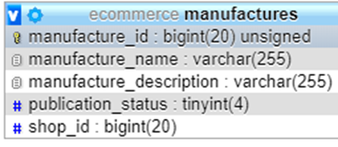 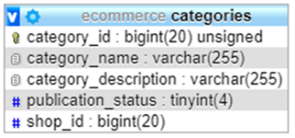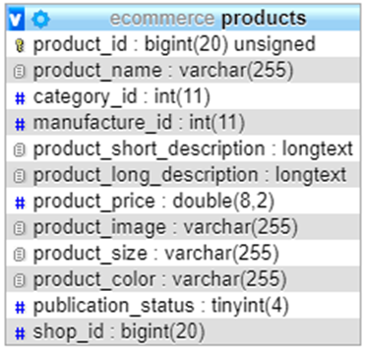

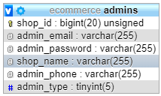 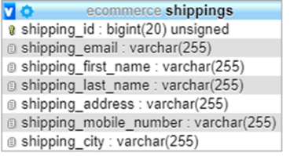

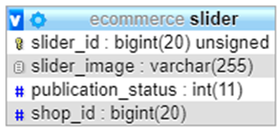 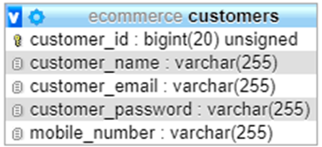

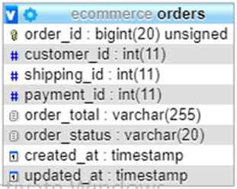 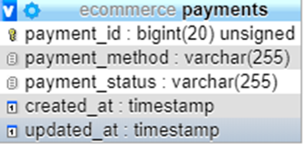

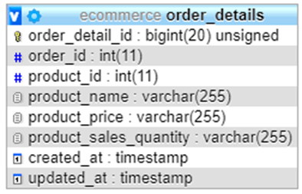

5.4 Table Design

Database is a collection of data that can be treated as a single unit. The single or individual unit is called a table. A relational database system Table is a combination of rows and columns which show records and fields respectively.

Determining all the entities we design the table structure as follows:

Table 1: Migrations

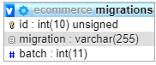

Table 2: Admins



Table 3: Secret_codes

C:\Users\Mahbub\Pictures\2.PNG

Table 4: Manufactures

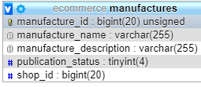

Table 5: Categories

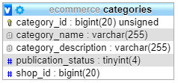

Table 6: Products

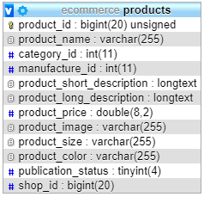

Table 7: Slider

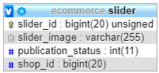

Table 8: Customers

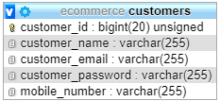

Table 9: Orders

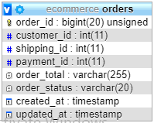

Table 10: Payments

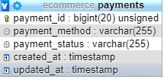

Table 11: Order_details

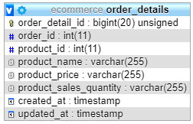

Table 12: Shipping

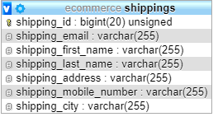

*Chapter Six*

System Implementation and Testing

**6.1 Project modules**

In the system implementation step, bootstrap, CSS, HTML are used to design various web forms based on tables used in Database.

**The project consists some major sections**

* Home
* Supper admin
* Admins
* Customers
* Manufactures
* Categories
* Products
* sliders
* About
* Contact Us

**6.2 Screens:**

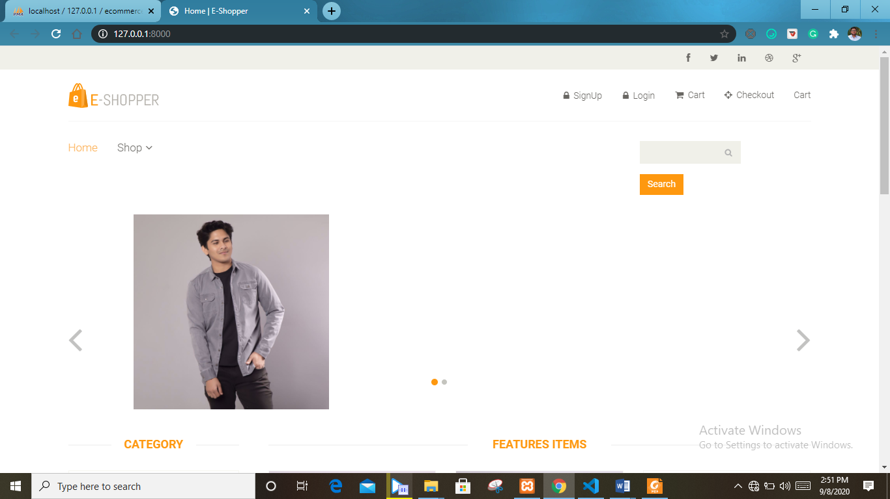

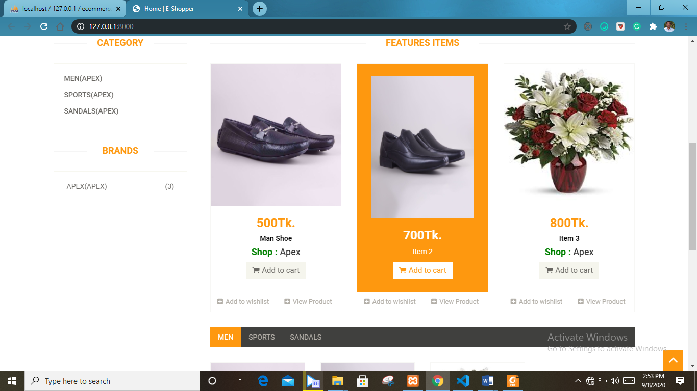

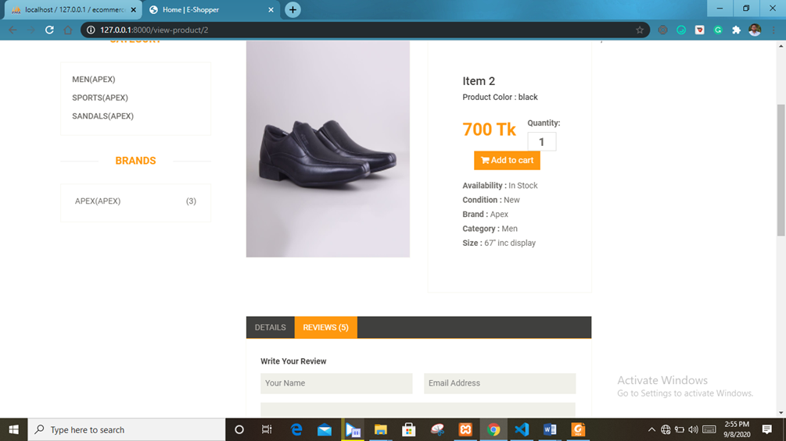

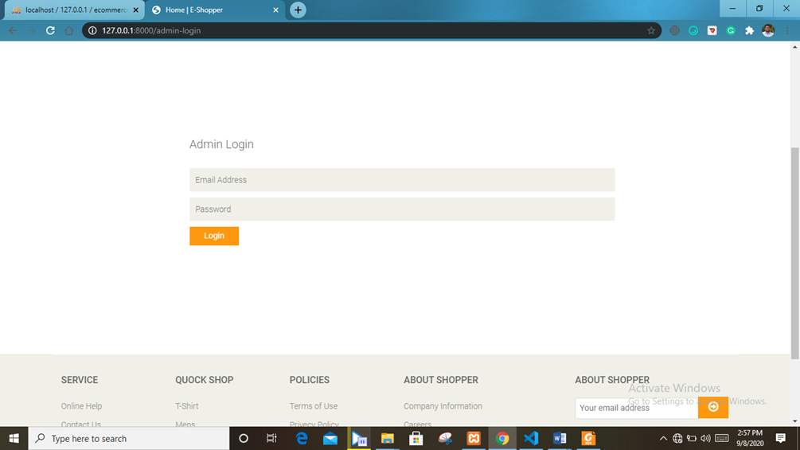

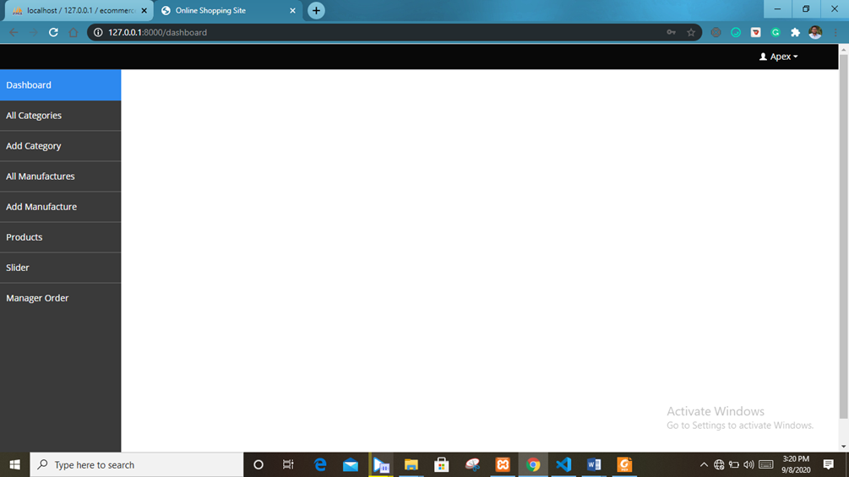

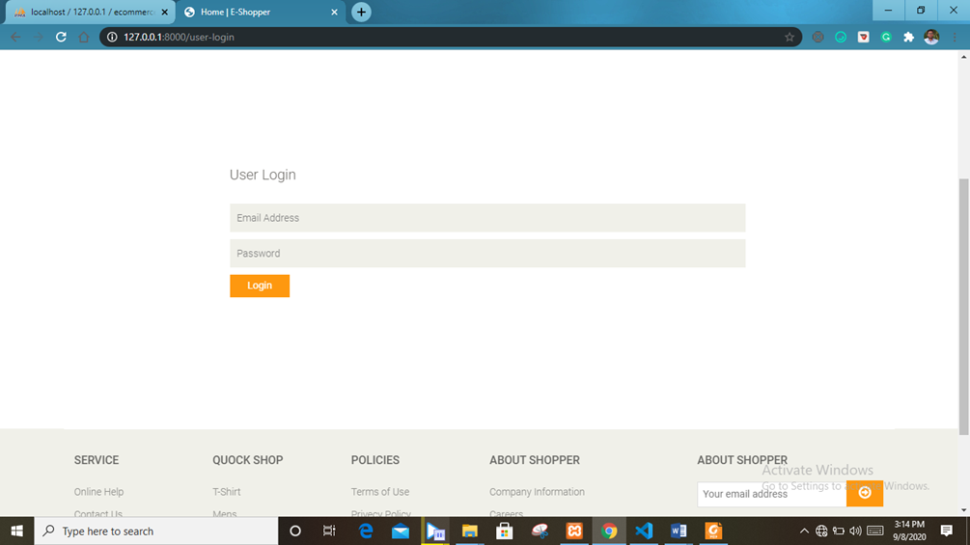

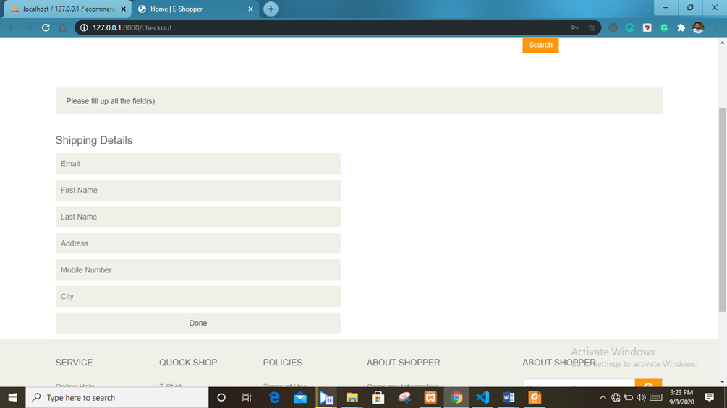

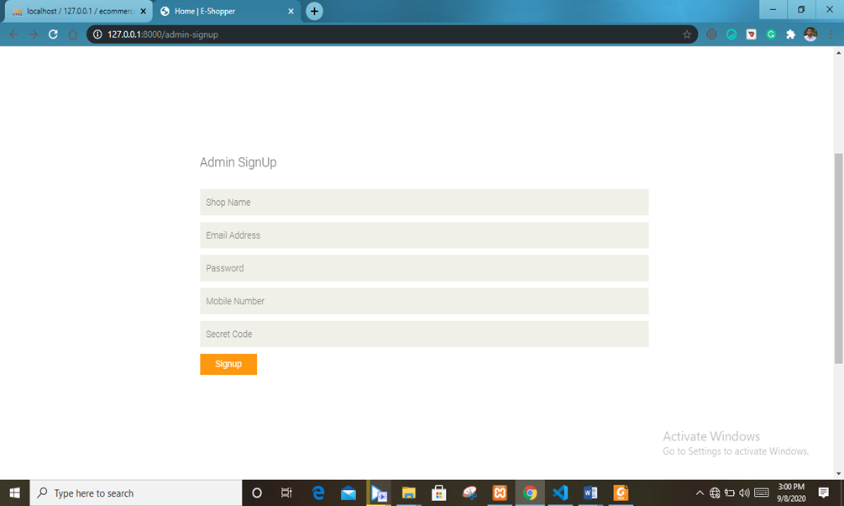

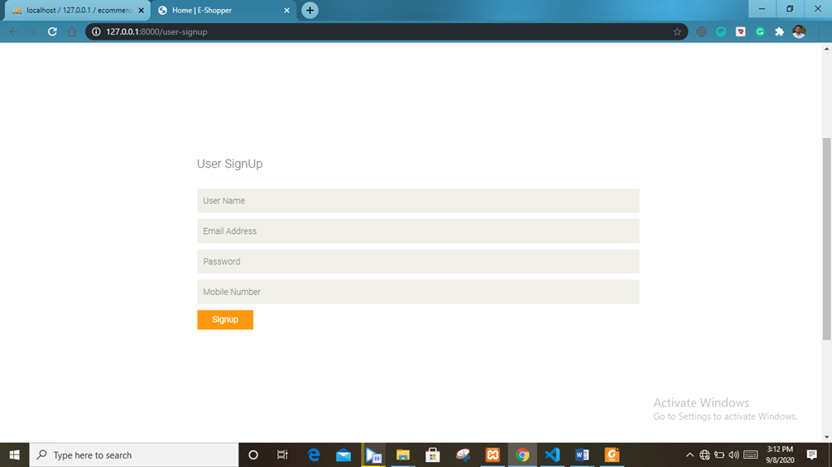

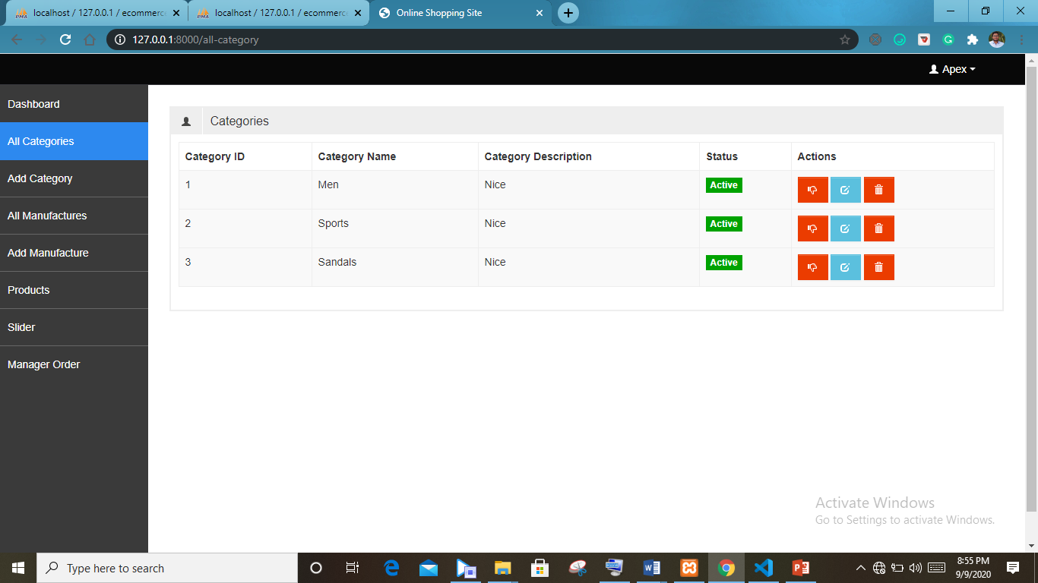

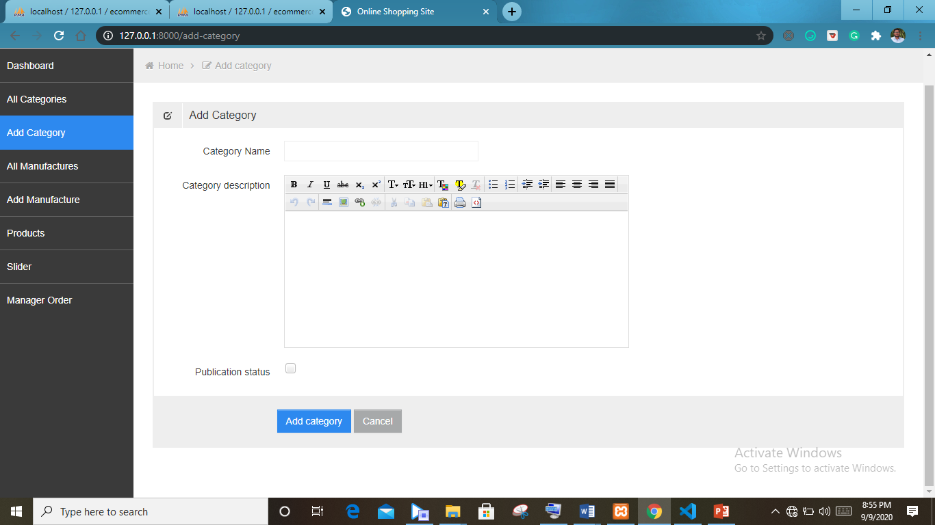

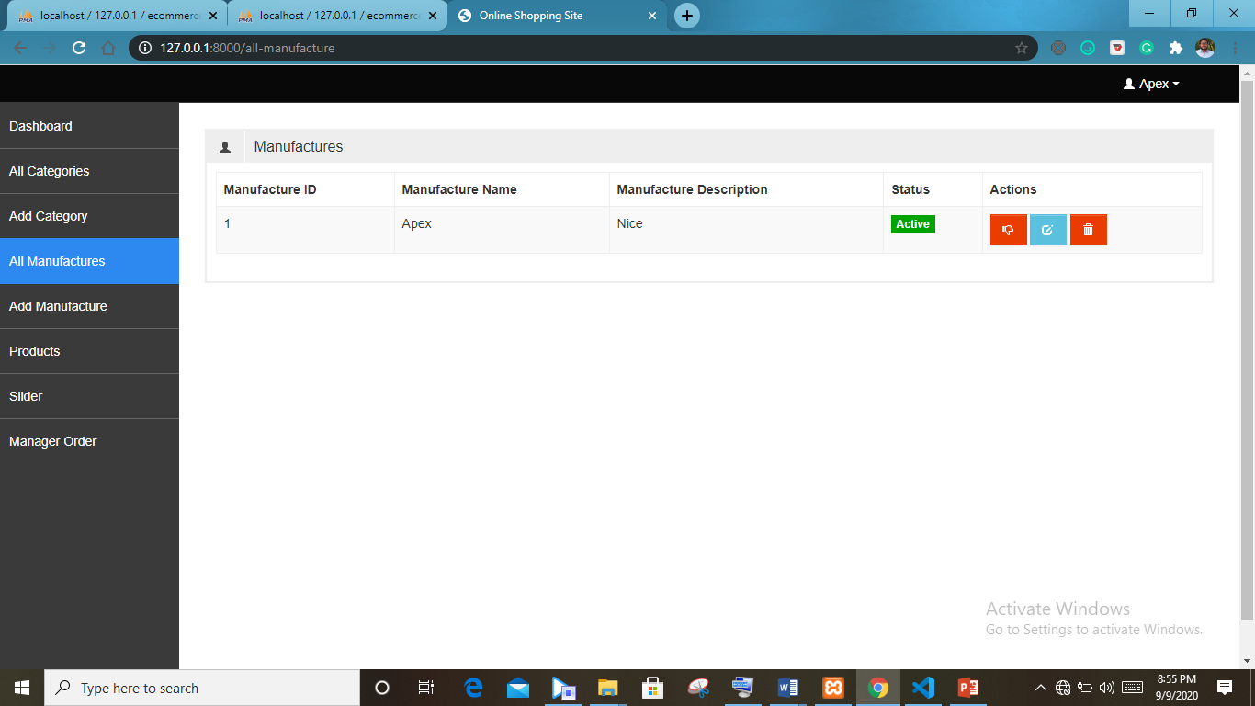

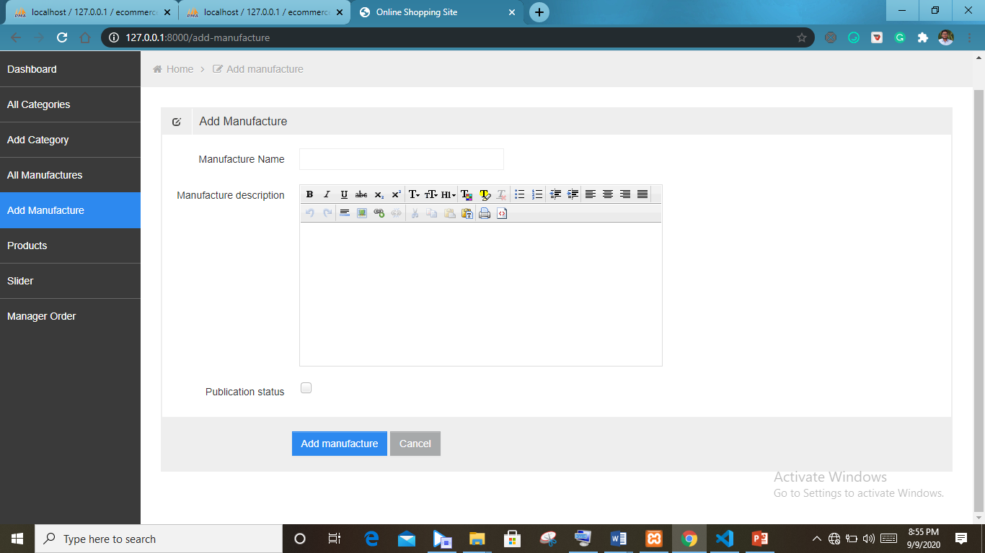

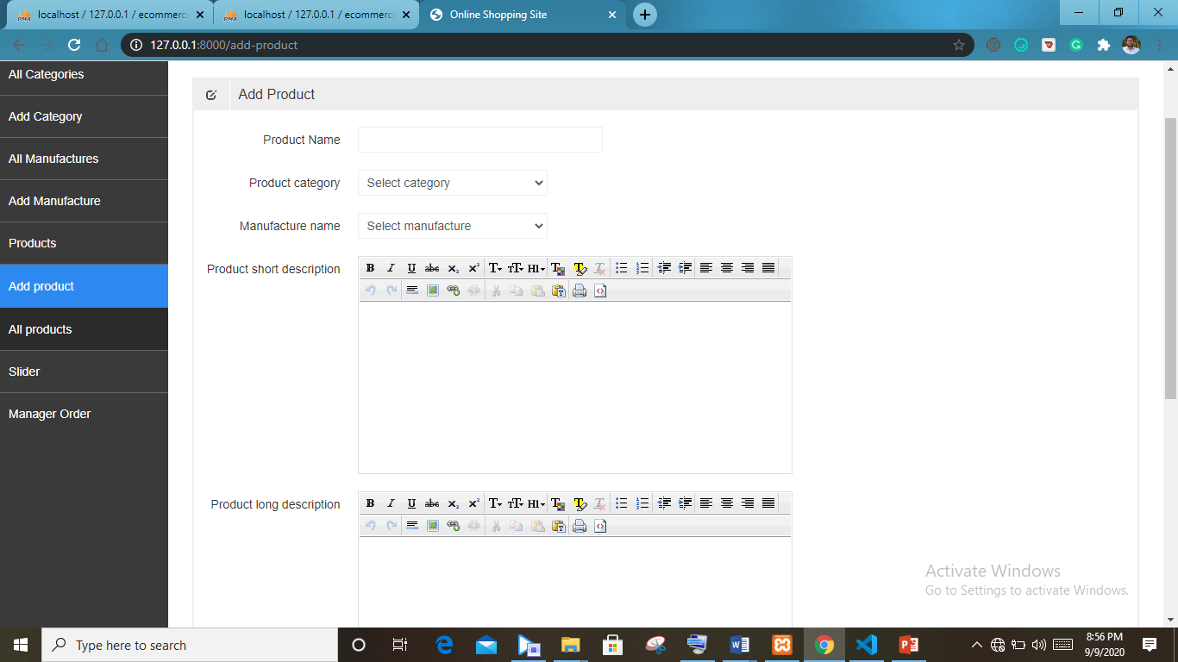

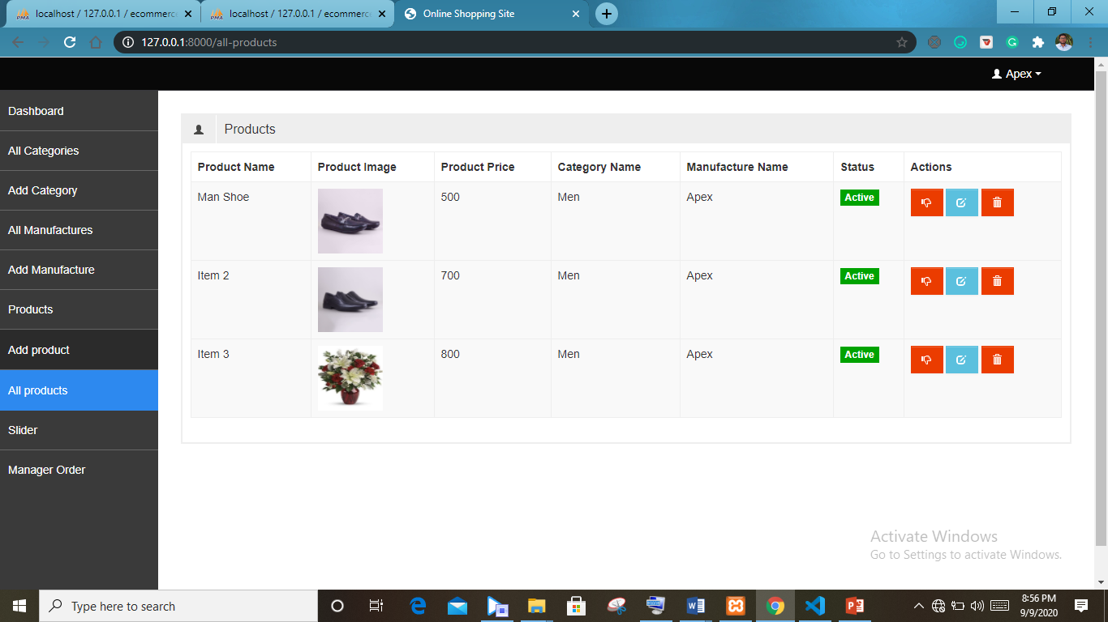

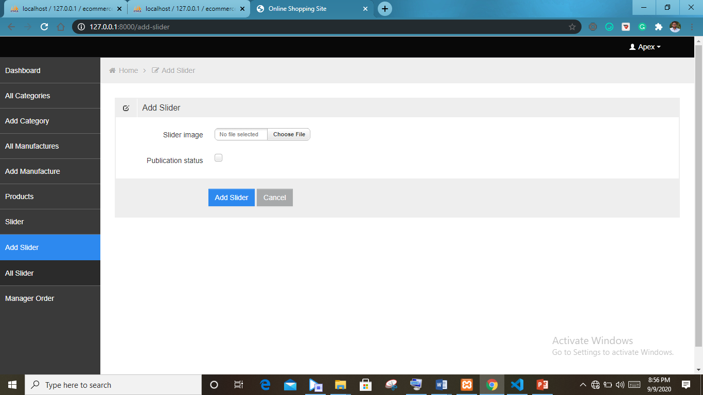

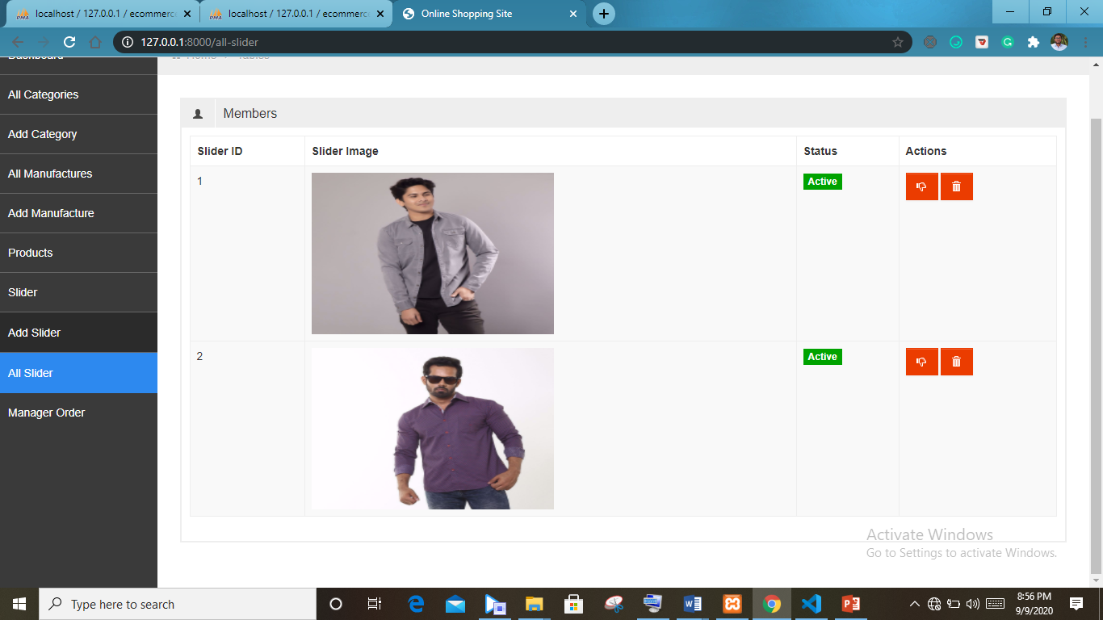

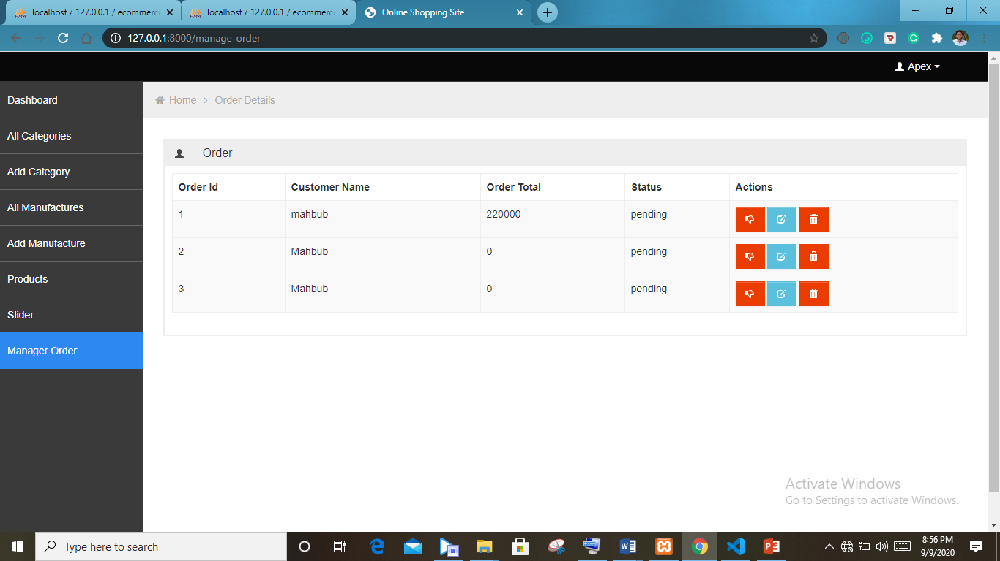

**6.3 Testing**

After coding, the code is tested by running the program to see whether the code written just acts expectedly or not for a particular task. The site is tested over one month by various prominent professionals. According to their suggestion and the result of the testing the whole site is modified at various times. In this way the whole web site is tested to see whether it works expectedly and performances of the web site is satisfactory.

**Content Testing**

Here, we uncover in the content those are present as a part of virtually every web application. This type of testing is Similar in many respects to copying tor as a document. Here development time is house.

**Interface testing**

Exercises interaction mechanisms and validities aesthetic aspects of the user interface. The intent is to uncover errors that are poorly implemented.

**Navigation testing**

Navigation link: this mechanism include internal link with in the web app external link to other web apps and anchors within a specific web page

Redirect: this link comes into play when a user requests a nonexistent URL of select and a link whose destination has been removed or whose name has changed.

Bookmarks: although bookmarks are a browser function, the web app should be tested to ensure that a meaningful page that can be extracted as the bookmark is created and that dynamic pages are bookmarked appropriately.

**Internal search engine:**

An internal search engine allows the admin to perform as Search within the web app to find desired student

**Configuration testing**

Configuration variability and instability are important factors that make web engineering a challenge. Hardware, operating system, browser, storage capacity, network communication speeds and a variety of other client's side factors are difficult to predict for each user. The job of Configuration testing is to test a set of probable client side and server side Configuration to ensure that the user experience will be the same on all of them and so isolated errors that may be specific to particular Configuration

**Security Testing**

Authentication: A verification mechanism that validates the identity of all clients and servers, allowing communication to occur only when both sides are verified.

Authorization: a filtering mechanism that allows access to the client or server environment only by those individuals with appropriate authorization codes.

*Chapter Seven*

Conclusion

7**.1 Limitations**

* Less Integrated system.
* Page Design (Look and Feel) and color combination is not too locative.
* Security problem.

**7.2 Future plan**

* Provide security for office members.
* A forum will be added in the web application for sharing opinions.
* Framework will be used for developing the Web App easily.
* System will be more integrated.
* Database system will be improved
* the system will be more dynamic.
* AR (Augmented Reality) will be use for virtual trail.

**7.3 Conclusion**

We have successfully implemented the site ‘**ECOMMERCE SITE FOR ONLINE SHPOING**’. With the help of various links and tools, we have been able to provide a site which will be live soon and running on the web. We have been successful in our attempt to take care of the needs of both the user as well as the administrator. Finally we hope that this will go a long way in popularizing.

REFERENCES:  
  
1. PHP Developers' Cookbook by STERLING HUGHES.  
2. Learning PHP, MySQL & JavaScript: With jQuery, CSS, HTML5 by Robin Nixon.  
3. www.w3school.com  
4. www.github.com  
5. [www.tuutorialspoint.com](http://www.tcutorialspoint.com/?fbclid=IwAR0CstjgsNY9xEfLJwitSYfHIagCRm7C6_b6D2ccRUwFsAHaKU-DVGf88Hk)  
6. [www.wikipedia.com](http://www.wikipedia.com/?fbclid=IwAR2JSVxcp_ca9mT89gl5BeUVNYu_UeT0f87Ju6mnxxtPf_shw20uxOvT49I)  
7. [www.webopedia.com](http://www.webopedia.com/?fbclid=IwAR07PvCdjqbumrC2HF0dxd0hx2iImxp5g_Jhz4_eXdu45lqAyZgYGQbCxb0)  
8. [www.mysql.co](https://l.facebook.com/l.php?u=http%3A%2F%2Fwww.mysql.co%2F%3Ffbclid%3DIwAR369m0hbq6N1kV4hfGy3DI5EK7dI6E-ZHogQaZDnSR-A99EH6qWu8Xp8gY&h=AT3e208W1ocjMlLM5H0MgRBKsMq_VGPUMhsXrjFzU3an8_U6lFZAPNES-mfVAsDa3KIBvB6YrIaiVHtFAkwKvuZFAqVfQimODk4cSKPZ7Wz653G9-bViYBkAslznvEKJ13FjJQ)m  
9. System analysis and design by Eias M Awad